**Remove Nth Node From End of List**

Medium

11327518Add to ListShare

Given the head of a linked list, remove the nth node from the end of the list and return its head.

**Example 1:**

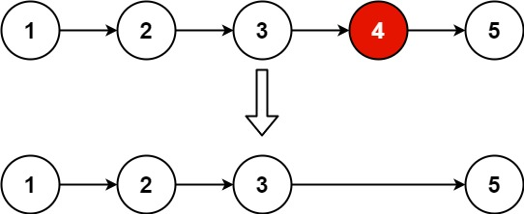

**Input:** head = [1,2,3,4,5], n = 2

**Output:** [1,2,3,5]

**Example 2:**

**Input:** head = [1], n = 1

**Output:** []

**Example 3:**

**Input:** head = [1,2], n = 1

**Output:** [1]

/**

* Definition for singly-linked list.

* public class ListNode {

* int val;

* ListNode next;

* ListNode() {}

* ListNode(int val) { this.val = val; }

* ListNode(int val, ListNode next) { this.val = val; this.next = next; }

* }

*/

class Solution {

public ListNode removeNthFromEnd(ListNode head, int n) {

ListNode fast = head, slow = head;

for (int i = 0; i < n; i++)

fast = fast.next;

if (fast == null)

return head.next;

while (fast.next != null) {

fast = fast.next;

slow = slow.next;

}

slow.next = slow.next.next;

return head;

}

}